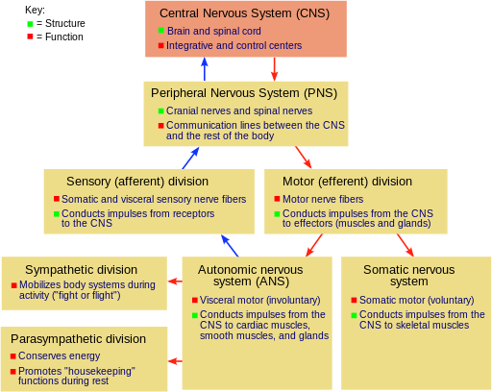

**The Structure And Function Of The Human Brain**

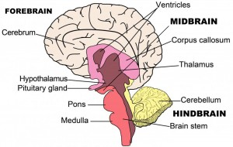The brain structure is composed of three main parts: the forebrain, midbrain and hindbrain, each with multiple parts.

**Forebrain**

**The Cerebrum**: Also known as the cerebral cortex, the cerebrum is the largest part of the human brain, and it is associated with higher brain function such as thought and action. Nerve cells make up the gray surface, which is a little thicker than our thumb. White nerve fibers beneath the surface carry signals between nerve cells in other parts of the brain and body. Its wrinkled surface increases the surface area, and is a six-layered structure found in mammals, called the neocortex. It is divided into four sections, called “lobes”. They are; the frontal lobe, the parietal lobe, the occipital lobe and the temporal lobe.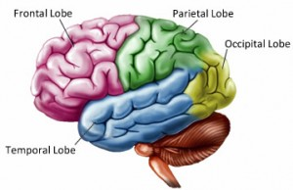

**Functions Of The Lobes:**

**Frontal Lobe** – The frontal lobe lies just beneath our forehead and is associated with our brain’s ability to reason, organize, plan, speak, move, make facial expressions, serial task, problem solve, control inhibition, spontaneity, initiate and self-regulate behaviors, pay attention, remember and control emotions.

**Parietal Lobe** – The parietal lobe is located at the upper rear of our brain, and controls our complex behaviors, including senses such as vision, touch, body awareness and spatial orientation. It plays important roles in integrating sensory information from various parts of our body, knowledge of numbers and their relations, and in the manipulation of objects. Portions are involved with our visuospatial processing, language comprehension, the ability to construct, body positioning and movement, neglect/inattention, left-right differentiation and self-awareness/insight.

**Occipital Lobe** – The occipital lobe is located at the back of our brain, and is associated with our visual processing, such as visual recognition, visual attention, spatial analysis (moving in a 3-D world) and visual perception of body language; such as postures, expressions and gestures.

**Temporal Lobe** – The temporal lobe is located near our ears, and is associated with processing our perception and recognition of auditory stimuli (including our ability to focus on one sound among many, like listening to one voice among many at a party), comprehending spoken language, verbal memory, visual memory and language production (including fluency and word-finding), general knowledge and autobiographical memories.

A deep furrow divides the cerebrum into two halves, known as the left and right hemispheres. And, while the two hemispheres look almost symmetrical, each side seems to function differently. The right hemisphere is considered our creative side, and the left hemisphere is considered our logical side. A bundle of axons, called the corpus callosum, connects the two hemispheres.

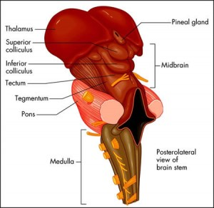

**Midbrain**

The midbrain is located below the cerebral cortex, and above the hindbrain placing it near the center of the brain. It is comprised of the tectum, tegmentum, cerebral aqueduct, cerebral peduncles and several nuclei and fasciculi. The primary role of the midbrain is to act as a sort of relay station for our visual and auditory systems. Portions of the midbrain called the red nucleus and the substantia nigra are involved in the control of body movement, and contain a large number of dopamine-producing neurons. The degeneration of neurons in the substantia nigra is associated with Parkinson’s disease. The midbrain is the smallest region of the brain, and is located most centrally within the cranial cavity.

**Limbic System** – the limbic system is often referred to as our “emotional brain”, or ‘childish brain’. It is found buried within the cerebrum and contains the thalamus, hypothalamus, amygdala and hippocampus.

**Thalamus** – the primary role of the thalamus is to relay sensory information from other parts of the brain to the cerebral cortex

**Hypothalamus** – the primary role of the hypothalamus is to regulate various functions of the pituitary gland and endocrine activity, as well as somatic functions e.g.body temperature, sleep, appetite.

**Amygdala** – the primary role of the amygdala is to be a critical processor for the senses. Connected to the hippocampus, it plays a role in emotionally laden memories and contains a huge number of opiate receptor sites that are implicated in rage, fear and sexual feelings.

**Hippocampus** – the primary role of the hippocampus is memory forming, organizing and storing information. It is particularly important in forming new memories, and connecting emotions and senses, such as smell and sound, to memories.

**Pituitary Gland** – the primary role of the pituitary gland is an important link between the nervous system and the endocrine system. It releases many hormones which affect growth, metabolism, sexual development and the reproduction system. It is connected to the hypothalamus and is about the size of a pea. It is located in the center of the skull, just behind the bridge of the nose.

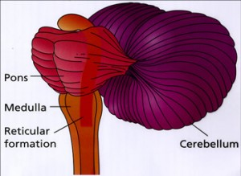

**Hindbrain**

**The Cerebellum** – The cerebellum, or “little brain”, is similar to the cerebrum with its two hemispheres and highly folded surface. It is associated with regulation and coordination of movement, posture, balance and cardiac, respiratory and vasomotor centers.

**Brain Stem** – The brain stem is located beneath the limbic system. It is responsible for vital life functions such as breathing, heartbeat, and blood pressure. The brain stem is made of the midbrain, pons, and medulla.

**Pons** – The primary role of the pons is to serve as a bridge between various parts of the nervous system, including the cerebellum and cerebrum. Many important nerves that originate in the pons, such as the trigeminal nerve, responsible for feeling in the face, as well as controlling the muscles that are responsible for biting, chewing, and swallowing. It also contains the abducens nerve, which allows us to look from side to side and the vestibular cochlear nerve, which allows to hear. As part of the brainstem, a section of the lower pons stimulates and controls the intensity of breathing, while a section of the upper pons decreases the depth and frequency of breaths. The pons is also associated with the control of sleep cycles, and controls respiration and reflexes. It is located above the medulla, below the midbrain, and just in front of the cerebellum.

**Medulla**– The primary role of the medulla is regulating our involuntary life sustaining functions such as breathing, swallowing and heart rate. As part of the brain stem, it also helps transfer neural messages to and from the brain and spinal cord. It is located at the junction of the spinal cord and brain.

The spinal cord

The spinal cord is a long, fragile tube like structure that begins at the end of the brain stem and continues down almost to the bottom of the spine. The spinal cord consists of nerves that carry incoming and outgoing messages between the brain and the rest of the body. It is also the center for reflexes, such as the knee jerk reflex

**Anatomy of the Spine**

Like the brain, the spinal cord is covered by three layers of tissue (meninges). The spinal cord and meninges are contained in the spinal canal, which runs through the center of the spine. In most adults, the spine is composed of 33 individual back bones (vertebrae). Just as the skull protects the brain, vertebrae protect the spinal cord. The vertebrae are separated by disks made of cartilage, which act as cushions, reducing the forces generated by movements such as walking and jumping. The vertebrae and disks of cartilage extend the length of the spine and together form the vertebral column, also called the spinal column.

|  |  |
| --- | --- |
| D:\Documents and Settings\Mallika\My Documents\spinal cord.jpg | |
| **Spinal nerves:** Emerging from the spinal cord between the vertebrae are 31 pairs of spinal nerves. Each nerve emerges in two short branches (roots):   * One at the front (motor or anterior root) of the spinal cord * One at the back (sensory or posterior root) of the spinal cord   The **motor roots** carry commands from the brain and spinal cord to other parts of the body, particularly to skeletal muscles.  The **sensory roots** carry information to the brain from other parts of the body.  **Cauda equina:** The spinal cord ends about three fourths of the way down the spine, but a bundle of nerves extends beyond the cord. This bundle is called the cauda equina because it resembles a horse’s tail. The cauda equina carries nerve impulses to and from the legs. | |
|  | |

Like the brain, the spinal cord consists of gray and white matter. The butterfly-shaped center of the cord consists of gray matter. The front wings (also called horns) contain motor nerve cells (neurons), which transmit information from the brain or spinal cord to muscles, stimulating movement. The back horns contain sensory nerve cells, which transmit sensory information from other parts of the body through the spinal cord to the brain. The surrounding white matter contains columns of nerve fibers that carry sensory information to the brain from the rest of the body (ascending tracts) and columns that carry motor impulses from the brain to the muscles (descending tracts).

**Peripheral nervous system**

The **peripheral nervous system** (**PNS**), which consists of the neurons and parts of neurons found outside of the CNS, includes sensory neurons and motor neurons. Sensory neurons bring signals into the CNS, and motor neurons carry signals out of the CNS.

The cell bodies of some PNS neurons, such as the motor neurons that control skeletal muscle (the type of muscle found in your arm or leg), are located in the CNS. These motor neurons have long extensions (axons) that run from the CNS all the way to the muscles they connect with (innervate). The cell bodies of other PNS neurons, such as the sensory neurons that provide information about touch, position, pain, and temperature, are located outside of the CNS, where they are found in clusters known as **ganglia**.

The axons of peripheral neurons that travel a common route are bundled together to form **nerves**. 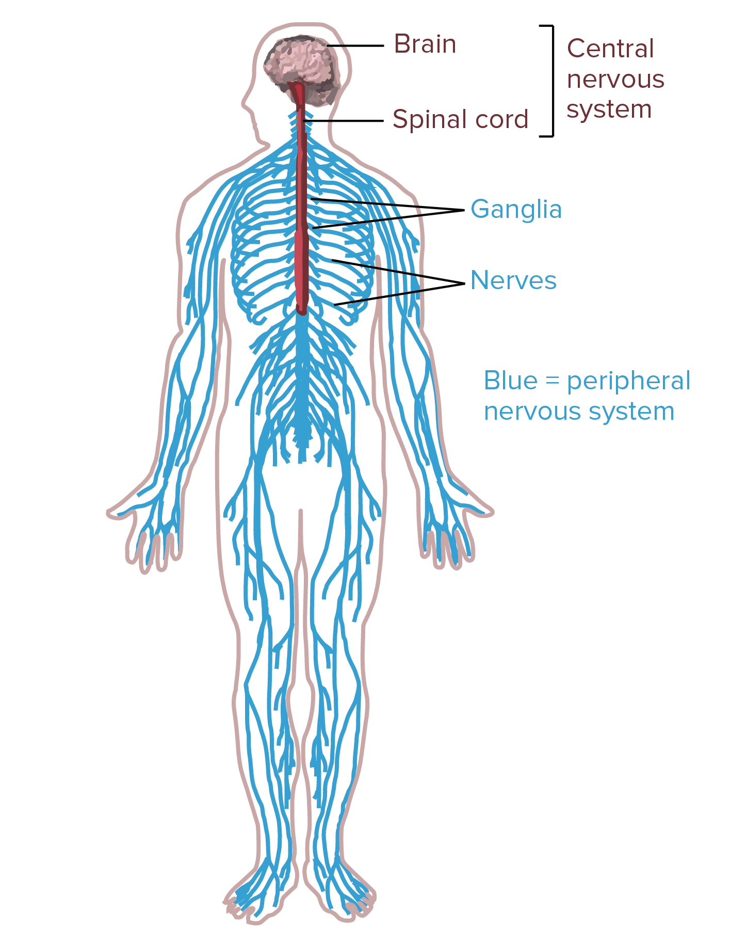

## Classes of neurons

Based on their roles, the neurons found in the human nervous system can be divided into three classes: sensory neurons, motor neurons, and interneurons.

### Sensory neurons

**Sensory neurons** get information about what's going on inside and outside of the body and bring that information into the CNS so it can be processed.

### Motor neurons

**Motor neurons** get information from other neurons and convey commands to your muscles, organs and glands.

### Interneurons

**Interneurons**, which are found only in the CNS, connect one neuron to another. They receive information from other neurons (either sensory neurons or interneurons) and transmit information to other neurons (either motor neurons or interneurons).

## The basic functions of a neuron

If you think about the roles of the three classes of neurons, you can make the generalization that all neurons have three basic functions. These are to:

1. Receive signals (or information).
2. Integrate incoming signals (to determine whether or not the information should be passed along).
3. Communicate signals to target cells (other neurons or muscles or glands).

These neuronal functions are reflected in the anatomy of the neuron.

Anatomy of a neuron

Neurons, like other cells, have a cell body (called the **soma**). The nucleus of the neuron is found in the soma. Neurons need to produce a lot of proteins, and most neuronal proteins are synthesized in the soma as well.

Various **processes** (appendages or protrusions) extend from the cell body. These include many short, branching processes, known as **dendrites**, and a separate process that is typically longer than the dendrites, known as the**axon**.

### Dendrites

The first two neuronal functions, receiving and processing incoming information, generally take place in the dendrites and cell body. Incoming signals can be either **excitatory** – which means they tend to make the neuron**fire** (generate an electrical impulse) – or **inhibitory** – which means that they tend to keep the neuron from firing.

### Axons

The axon arises from the cell body at a specialized area called the **axon hillock**. Many axons are covered with a special insulating substance called **myelin**, which helps them convey the nerve impulse rapidly. Myelin is never found on dendrites. Towards its end, the axon splits up into many branches and develops bulbous swellings known as **axon terminals** (or **nerve terminals**). These axon terminals make connections on target cells.

### Synapses

Neuron-to-neuron connections are made onto the dendrites and cell bodies of other neurons. These connections, known as **synapses**, are the sites at which information is carried from the first neuron, the **presynaptic neuron**, to the target neuron (the **postsynaptic neuron**). The synaptic connections between neurons and skeletal muscle cells are generally called neuromuscular junctions, and the connections between neurons and smooth muscle cells or glands are known as neuroeffector junctions.

Thus, basic neuronal function – communicating information to target cells – is carried out by the axon and the axon terminals. Just as a single neuron may receive inputs from many presynaptic neurons, it may also make synaptic connections on numerous postsynaptic neurons via different axon terminals.

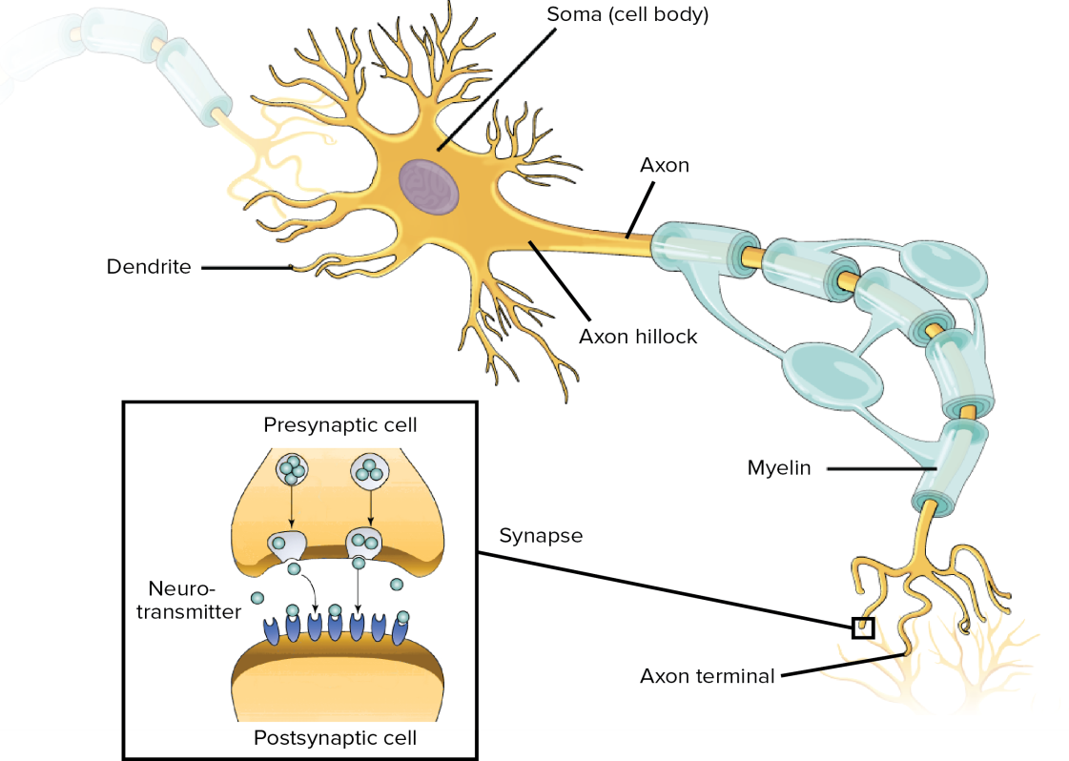

## Glands

Glands are important organs located throughout the body. They produce and release substances that perform certain functions. Though you have many glands throughout your body, they fall into two types: endocrine and exocrine.

Types of glands

Endocrine and exocrine glands serve very different purposes in the body.

### Endocrine glands

Endocrine glands are part of endocrine system. They make hormones and release them into bloodstream. These hormones control a number of important functions in body, such as:

* growth and development
* metabolism
* mood
* reproduction

endocrine glands include:

* [adrenal glands](https://www.healthline.com/health/adrenal-glands)
* [pituitary gland](https://www.healthline.com/human-body-maps/pituitary-gland)
* [hypothalamus](https://www.healthline.com/human-body-maps/hypothalamus)
* [thyroid](https://www.healthline.com/human-body-maps/thyroid-gland)
* [pineal gland](https://www.healthline.com/human-body-maps/pineal-gland)

There are also organs that contain endocrine tissue and act as glands. These include the:

* [pancreas](https://www.healthline.com/human-body-maps/pancreas)
* [kidneys](https://www.healthline.com/human-body-maps/kidney)
* [ovaries](https://www.healthline.com/human-body-maps/ovary)
* [testes](https://www.healthline.com/human-body-maps/testis)

### Exocrine glands

exocrine glands produce other substances — not hormones — that are released through ducts to the exterior of body, such as sweat, saliva, and tears.

The substances released by exocrine glands play important roles in your body. They do things like help regulate body temperature, protect your skin and eyes, and even help mothers feed babies by producing breast milk.

exocrine glands include:

* salivary
* sweat
* [mammary](https://www.healthline.com/human-body-maps/mammary-gland)
* sebaceous
* lacrimal

Lymph nodes are often referred to as glands, but they’re not true glands. They’re part of [immune system](https://www.healthline.com/health/cold-flu/fun-facts) and help body fight infection.

### Thyroid gland

thyroid gland is located in the front of neck, just below larynx. It measures approximately two inches and has a shape similar to a butterfly. It secretes hormones that affect virtually every tissue in body. Thyroid hormones regulate metabolism, heart, and digestive function. They also play a role in brain and nerve development, muscle control, and mood.

thyroid function is controlled by pituitary, which is a small gland at the base of brain.

### Pituitary gland

The pituitary gland is a pea-sized gland at the base of brain, just behind the bridge of nose. It’s controlled by the hypothalamus, which sits just above it. The pituitary gland is often called the master gland because it controls a number of other hormone glands, including the:

* thyroid
* adrenal gland
* testes
* ovaries

### Hypothalamus

The hypothalamus functions as a communication center for pituitary gland, sending signals and messages to the pituitary to produce and release hormones that trigger the production and release of other hormones. Hypothalamus influences a number of body’s functions, including:

* temperature regulation
* food intake
* [sleep and wakefulness](https://www.healthline.com/health/sleep-and-wakefulness)
* thirst
* memory
* emotional behavior

### Pineal gland

pineal gland is located deep in the center of brain. Its function is not completely understood, but we do know that it secretes and regulates certain hormones, including [melatonin](https://www.healthline.com/nutrition/melatonin). Melatonin helps regulate sleep patterns, which are also known as circadian rhythms. The pineal gland also plays a role in the regulation of female hormones, which affect the [menstrual cycle](https://www.healthline.com/health/womens-health/stages-of-menstrual-cycle) and fertility.

### Adrenal glands

adrenal glands are located at the top of each kidney. They produce various hormones, some of which include:

* cortisol
* aldosterone
* adrenaline
* a small amount of sex hormones called androgens

The hormones produced by adrenal glands have several important functions. They help body:

* control blood sugar
* burn fat and protein
* regulate blood pressure
* react to stressors

### Pancreas

The pancreas — a long, flat organ located in your abdomen — is made up of two types of glands: exocrine and endocrine. The pancreas is surrounded by the [small intestine](https://www.healthline.com/human-body-maps/small-intestine), [stomach](https://www.healthline.com/human-body-maps/stomach), [liver](https://www.healthline.com/human-body-maps/liver), [gallbladder](https://www.healthline.com/human-body-maps/gallbladder), and [spleen](https://www.healthline.com/health/what-does-the-spleen-do).

The pancreas plays an important role in converting the food eat into fuel for body’s cells. It does this by producing digestive [enzymes](https://www.healthline.com/health/why-are-enzymes-important) that are released into small bowel to break down and digest food. It also makes hormones that control blood [glucose](https://www.healthline.com/health/glucose) levels.

### Sweat glands

Skin is covered in sweat glands of which there are two types: eccrine and apocrine. Eccrine glands open directly onto skin and regulate body temperature by releasing water to the surface of skin when body temperature rises.

Apocrine glands open into the hair follicle and are found in hair-bearing areas, such as the skin, armpits, and groin. These glands secrete a milky fluid, usually as a response to stress. Body also contains modified apocrine glands:

* on the eyelids
* on the areola and nipples
* in the nose
* in the ears

### Sebaceous glands

Sebaceous glands are located throughout skin, though there are few on hands and feet and none on palms and soles. They secrete an oily substance called sebum that lubricates skin.

These glands perform a few functions in your body, such as:

* regulating body temperature by working with sweat glands
* helping skin retain moisture
* helping fight infection caused by bacteria and fungi

### Salivary glands

salivary glands are located in mouth. There are hundreds of small glands located throughout:

* tongue
* palate
* lips
* cheeks

Salivary glands produce saliva and empty into mouth through ducts. Saliva serves a few important purposes, including moistening your food to help chew, swallow, and digest it. Saliva also contains antibodies that kill germs to keep mouth healthy.

### Mammary glands

Mammary glands, which are a type of sweat gland, are responsible for the production of breast milk. Males also have glandular tissue in the breasts, but estrogen produced during [puberty](https://www.healthline.com/health/parenting/stages-of-puberty) triggers the growth of this tissue in females.

Hormonal changes during [pregnancy](https://www.healthline.com/health/pregnancy) signal the ducts to produce milk in preparation for the baby.